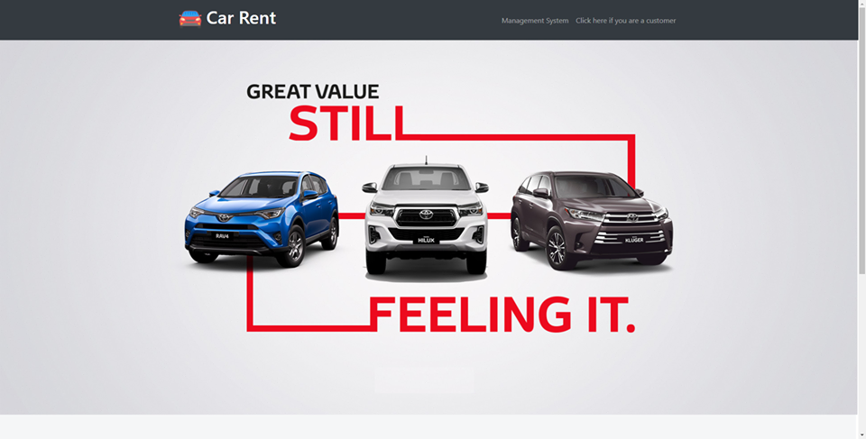

The welcome page which has two entries, one is for company staff and the other one is for customer. After clicking “management system”, the server will jump to login page

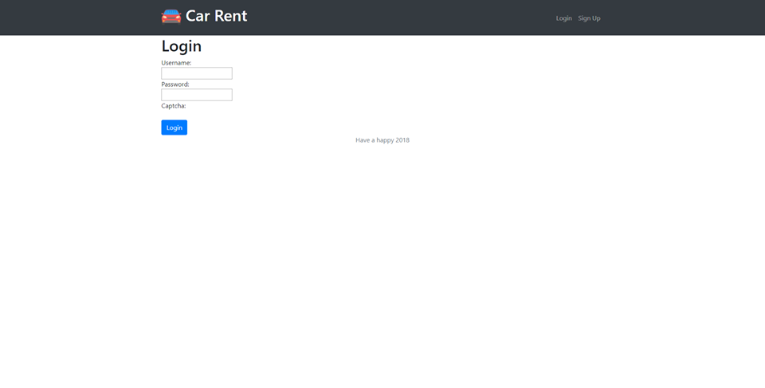

Is viewer already having a account, he can login directly, if does not, he have to sign up for the first time by clicking “sign up” hyperlink on the top right. After accessing into the management system, particularly browser page, there will be searching and sorting functions.

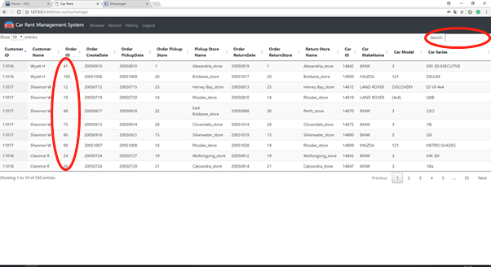

After sorted:

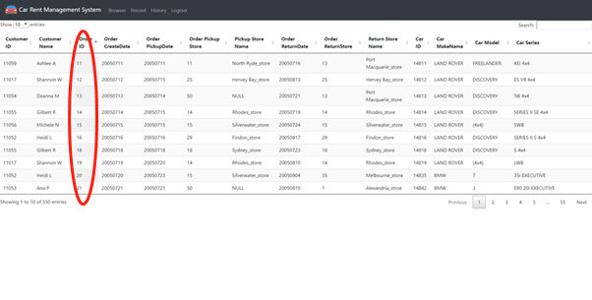

Go to Record page, we have three functions which are load new data, edit data and delete data.

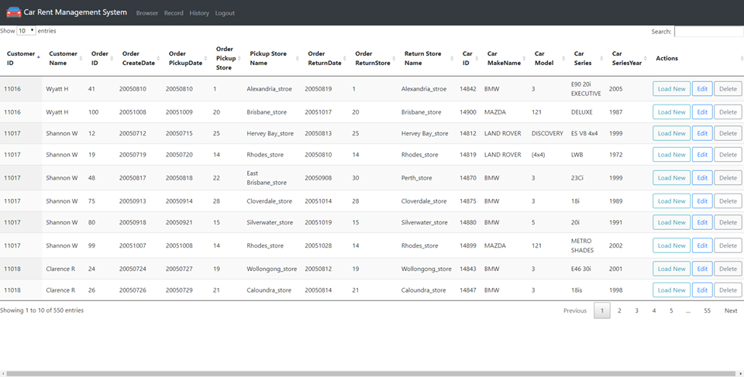

Load new data and editing page:

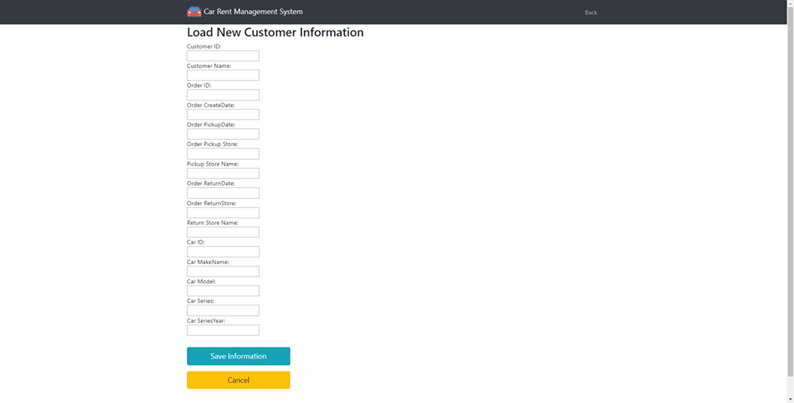

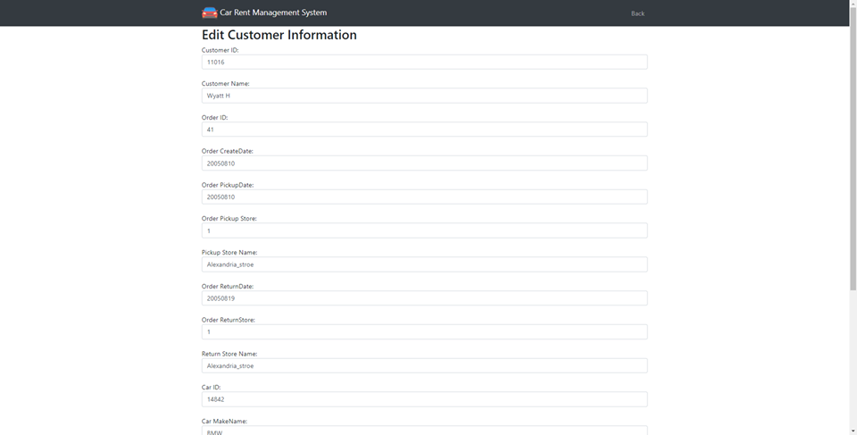

History menu can show all a happened order detail like below:

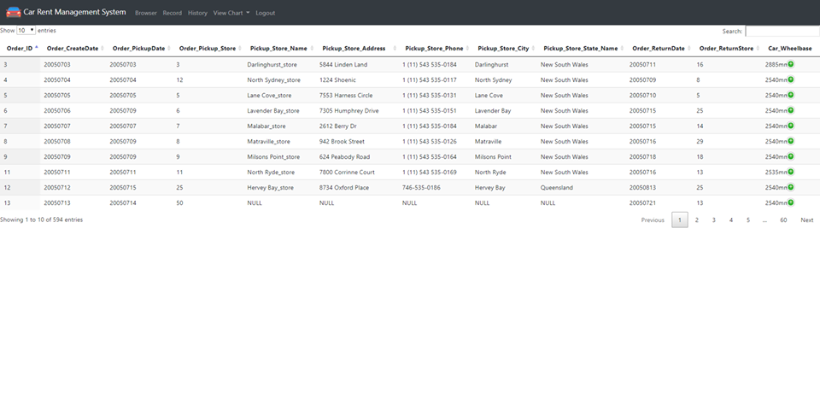

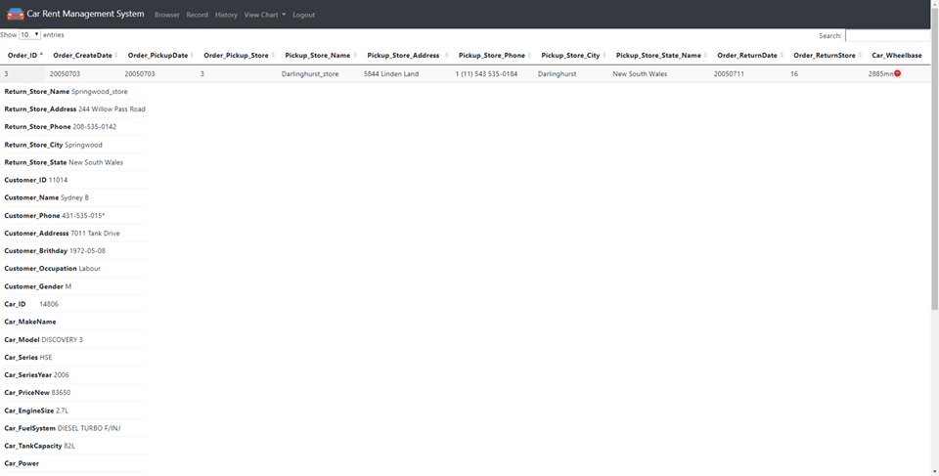

View charts can show company staff a clear pie chart and bar chart which helps them have a brief though on renting status. 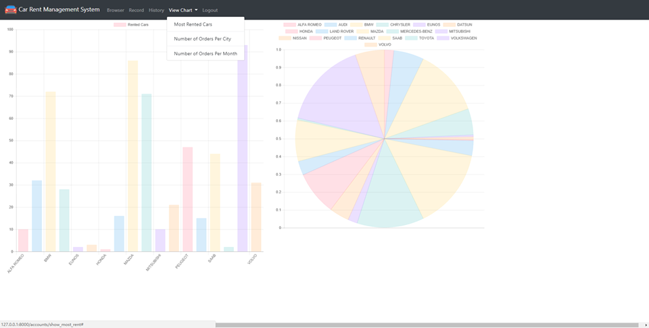

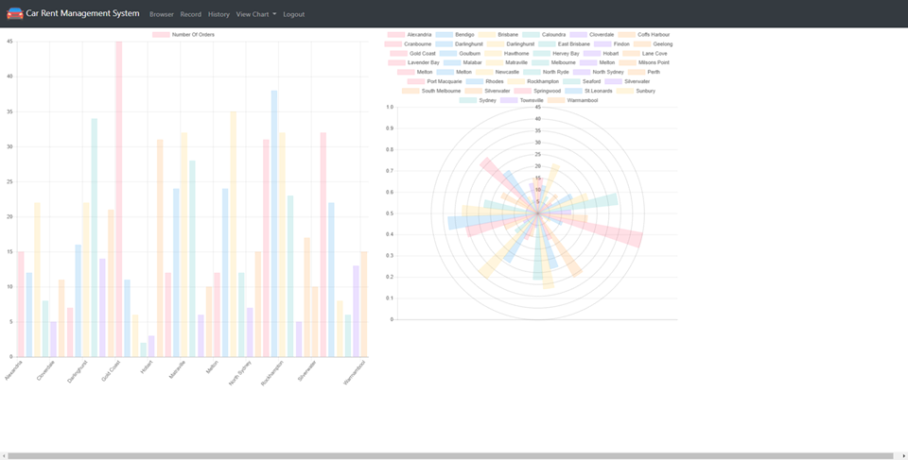

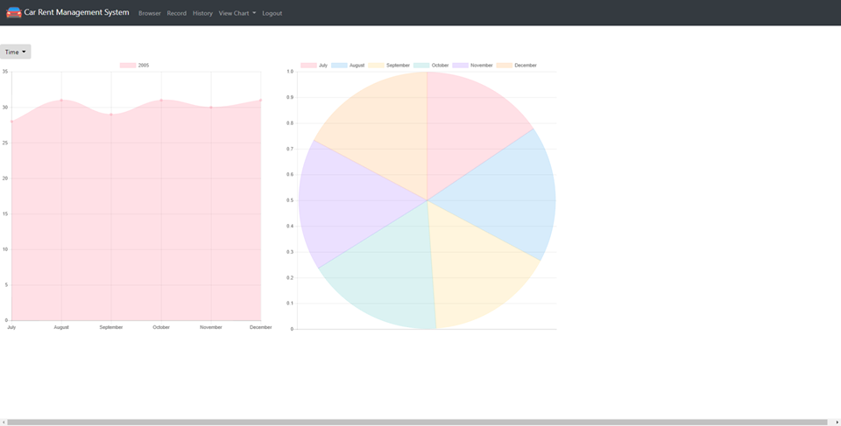

By clicking “if you are a customer”, customer can go to this page which has most popular rented cars and company’s contact details

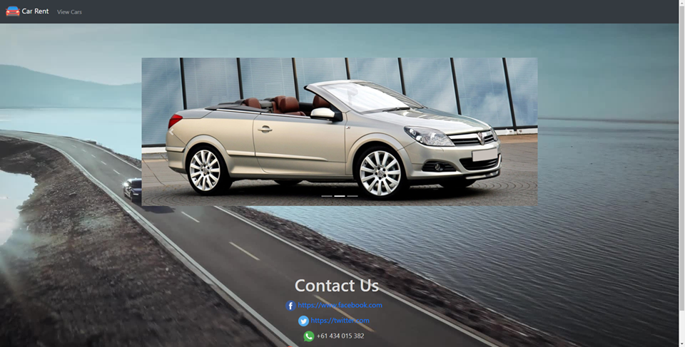

Click on “view cars” will go to car information page

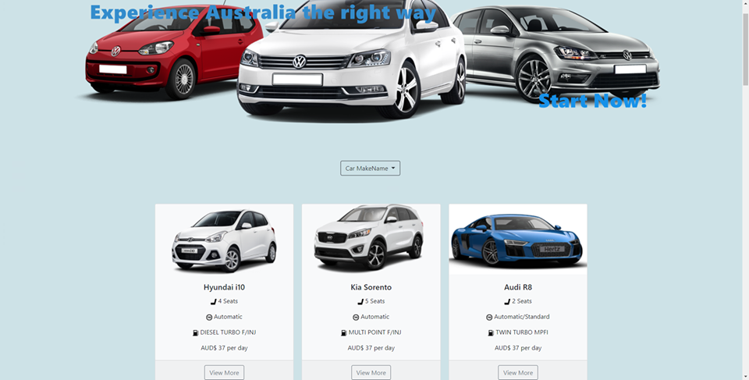

The “car Makename” drop down bar can filter cars by brand name

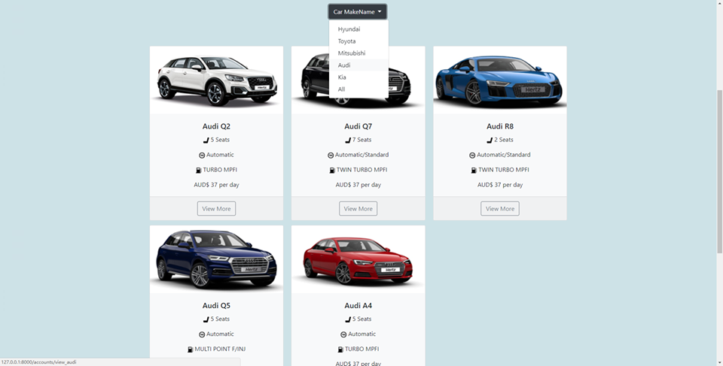

Each car information block has a button “view more”, click on that, and car detail information page will pop out.

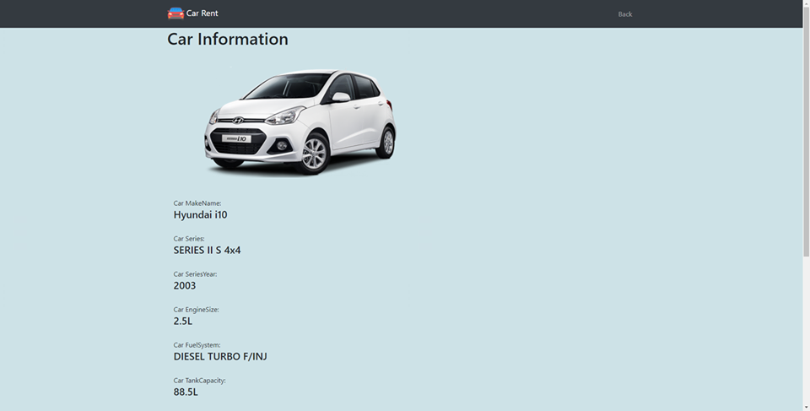

At the bottom of the web page, there are 2 buttons, one is save for later and another is back.

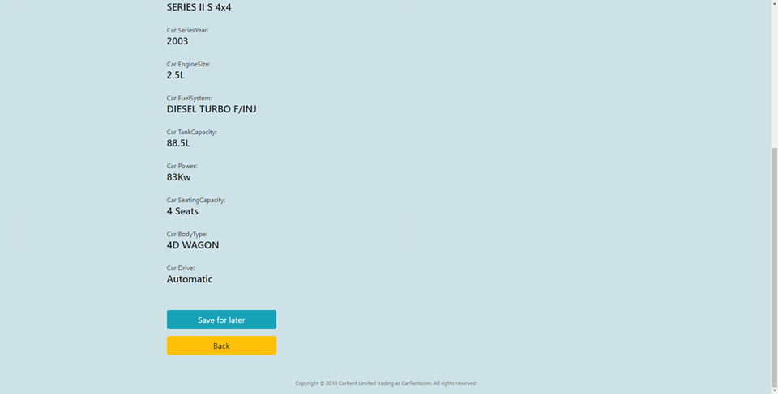

By clicking “save for later”, webserver will turn to email system and send customer the currently viewing car details, all customer have to do is input their personal email address in the recipient place.